35.16: (a) Dark fringe implies destructive interference.
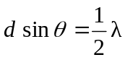
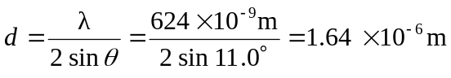
(b) Bright fringes: 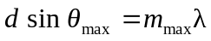
The largest that can be is 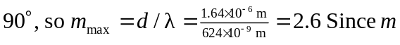 is an integer, its maximum value is 2. There are 5 bright fringes, the central spot and 2 on each side of it.
Dark fringes: 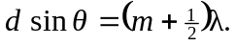 This equation has solutions for 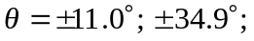 and 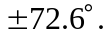 Therefore, there are 6 dark fringes.

